What is HTML?

Hyper Text Markup Language is a scripting language that defines the structure and content of web pages.

What is HTTP?

HTTP stands for Hypertext Transfer Protocol, and it's a protocol that allows web clients to request resources from web servers.

what is difference between http and https?

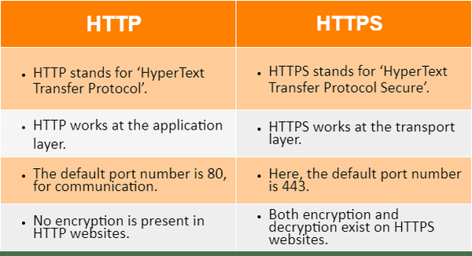

what is use of anchor tag?

The <a> HTML element (or anchor element), with its href attribute, creates a hyperlink to web pages, files, email addresses, locations in the same page, or anything else a URL can address.

what is use of href?

The href attribute used to link to another web page on the same domain or a different domain. href can also be used for other things, like linking to a different part of the same page, or serving a different web protocol than HTTPS.

what is difference between anchor tag and href?

Anchor tag is used to link another web page but, href is a attribute which we use for url of specification and location of linked document.

what Is diff between cellspacing and cellpadding?

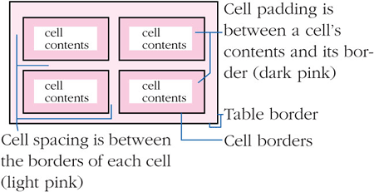

How many types of css are there?

[1. Inline CSS](https://www.geeksforgeeks.org/types-of-css-cascading-style-sheet/#inline-css)

[2. Internal or Embedded CSS](https://www.geeksforgeeks.org/types-of-css-cascading-style-sheet/#internal-or-embedded-css)

[3. External CSS](https://www.geeksforgeeks.org/types-of-css-cascading-style-sheet/#external-css)

what is the difference between internal and external css?

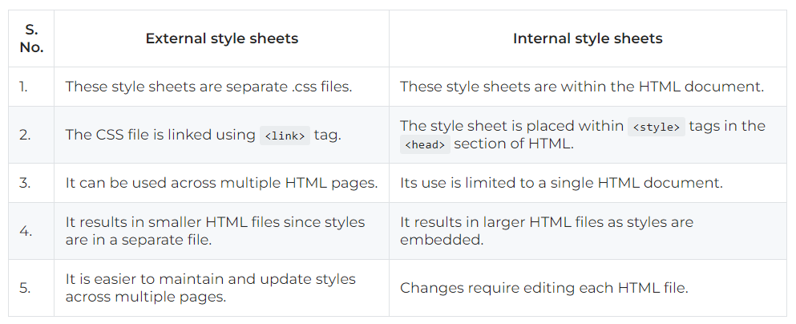

what are selectors used in css?

1. Universal Selector ( * )
2. Element Selector ( Element name (p/h1/div) )
3. ID selector ( #id_name )
4. Class Selector ( .class_name )
5. Attribute selector ( a[attribute] )